LAB NO: 4

LAB AIM: To implement the Decision Tree Classification algorithm on Dataset.

DATASET AND RESOURCES : winequality-red Dataset from kaggle and Python/Jupyter Notebook

DATE OF PERFORMANCE:21 -08 -2026

GITHUB REPO LINK :
https://github.com/Prabhkirat-Singh-Marwah/ML-PRACTICALS/tree/main/Practical-04

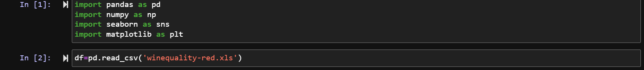
this command imports libraries and reads the file.

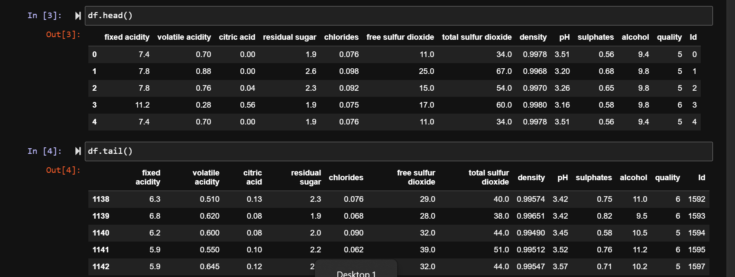df.head() prints first 5 rows and df.tail() prints last 5 rows of the dataset

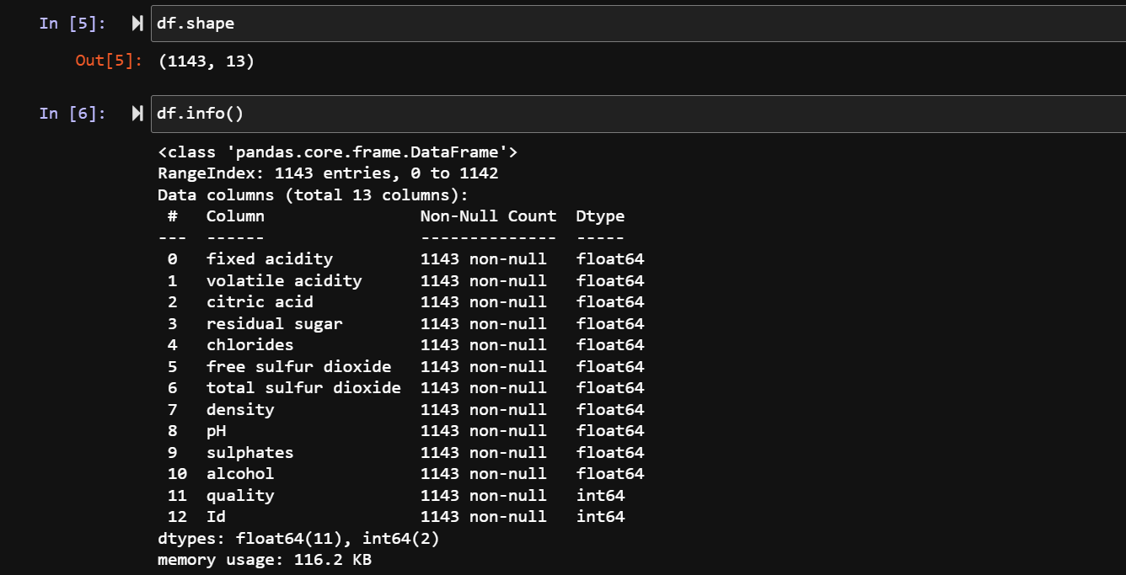
df.shape prints how many rows by columns is the dataset
df.info() prints number of rows, column name, memory used and datatypes

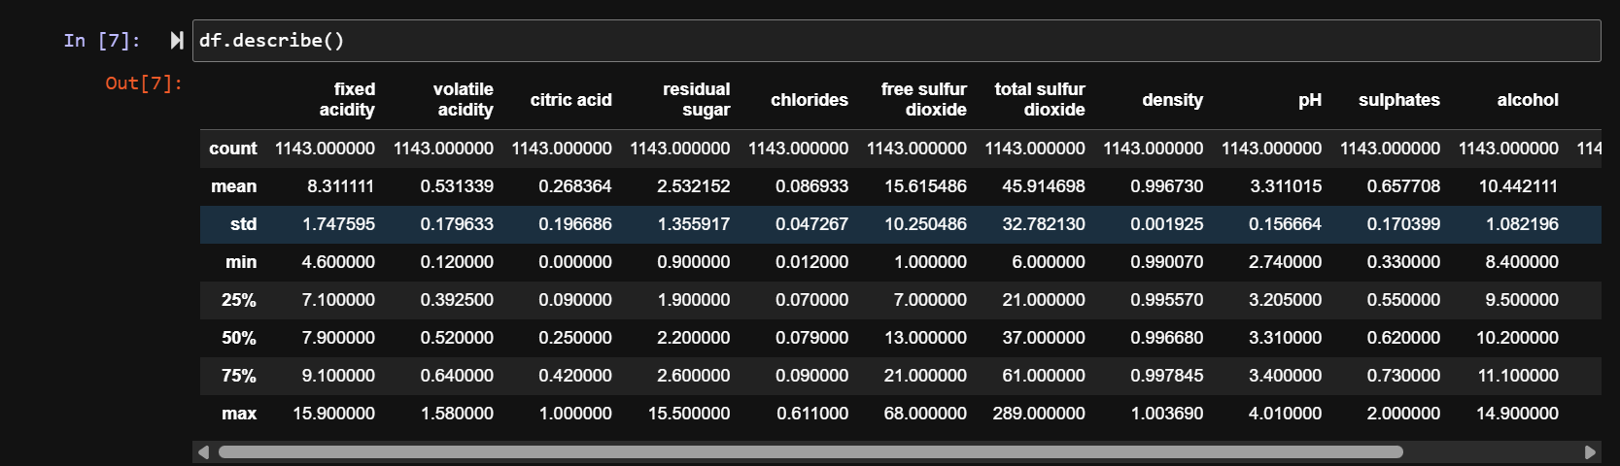this command gives a basic summary of statistical values like mean, average percentile, std deviation
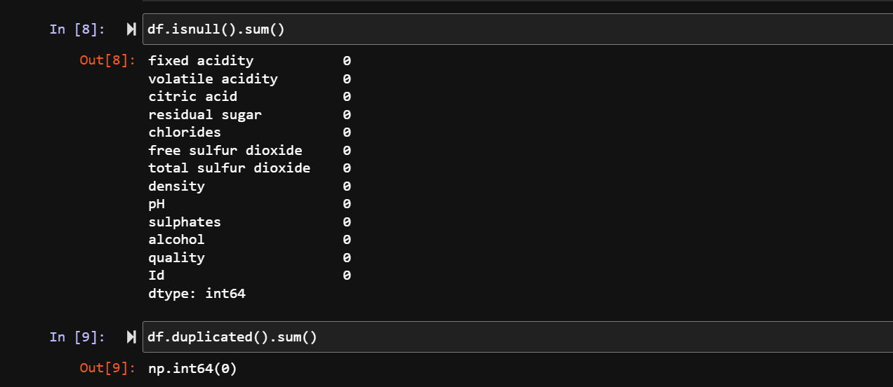these command prints if any null value exist and if yes, then it prints else it prints 0

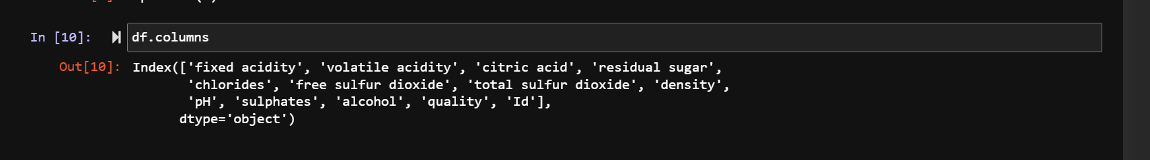this command prints the column heading names only

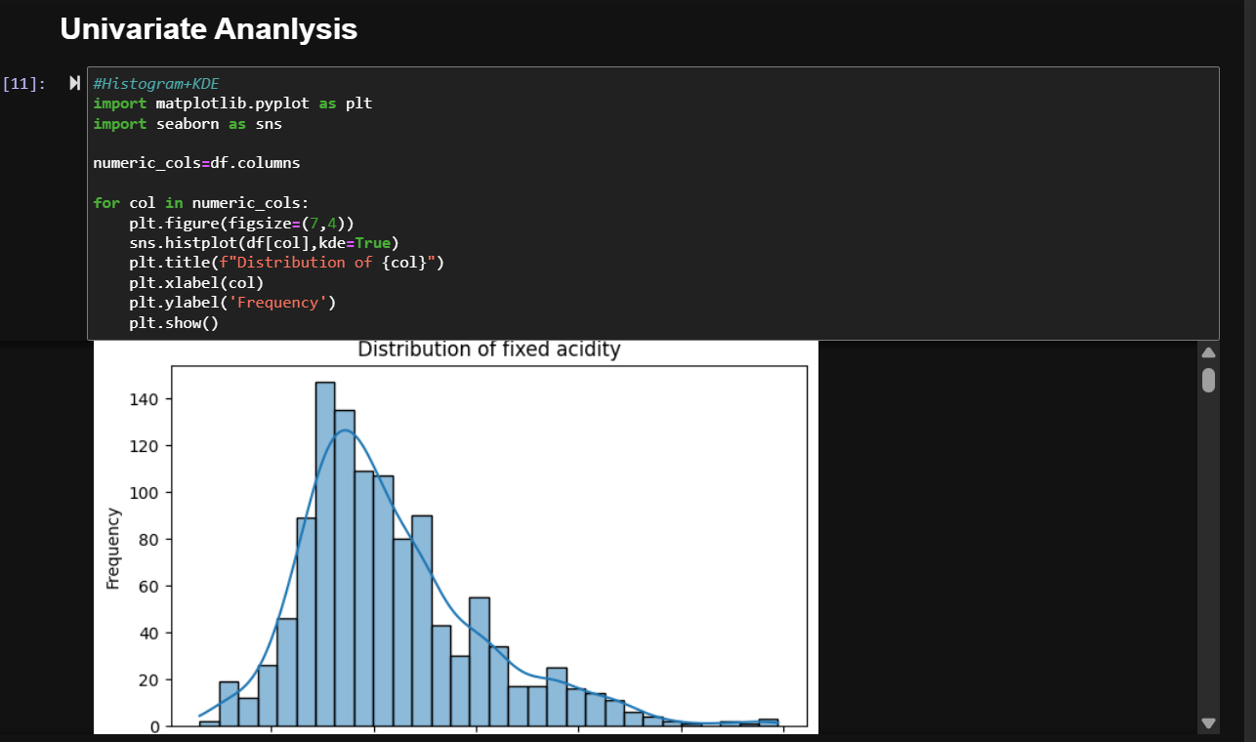this command draw histogram for all the column headings .
It is used for seeing how values are distributed in the dataset visually
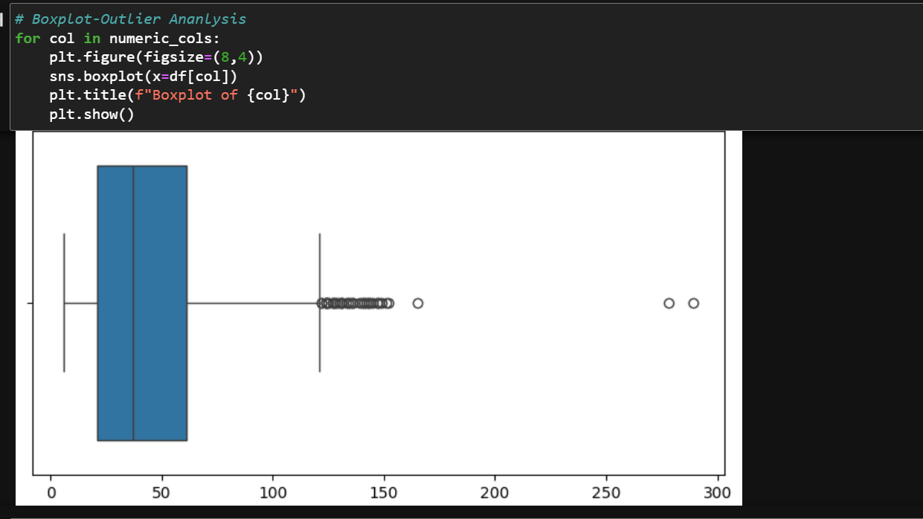
Boxplot is used to detect the outlier values in our dataset

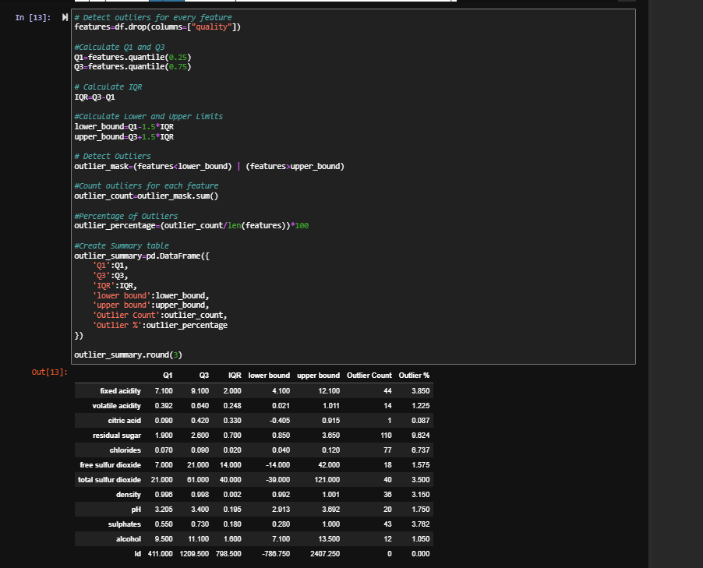
This command uses the first 25%ile and 75%ile for detecting outliers in the dataset
It calculates the interquartile range (IQR) meaning the values that lie in our desired range.
We then find the upperbound and lowerbound, values above upperbound and lower than lowerbound are outliers .
We then calculate total number of outlier % by formula of outliers/total data values*100
We then finally print the values calculated like outlier, iqr, upperbound , lowerbound, outlier %

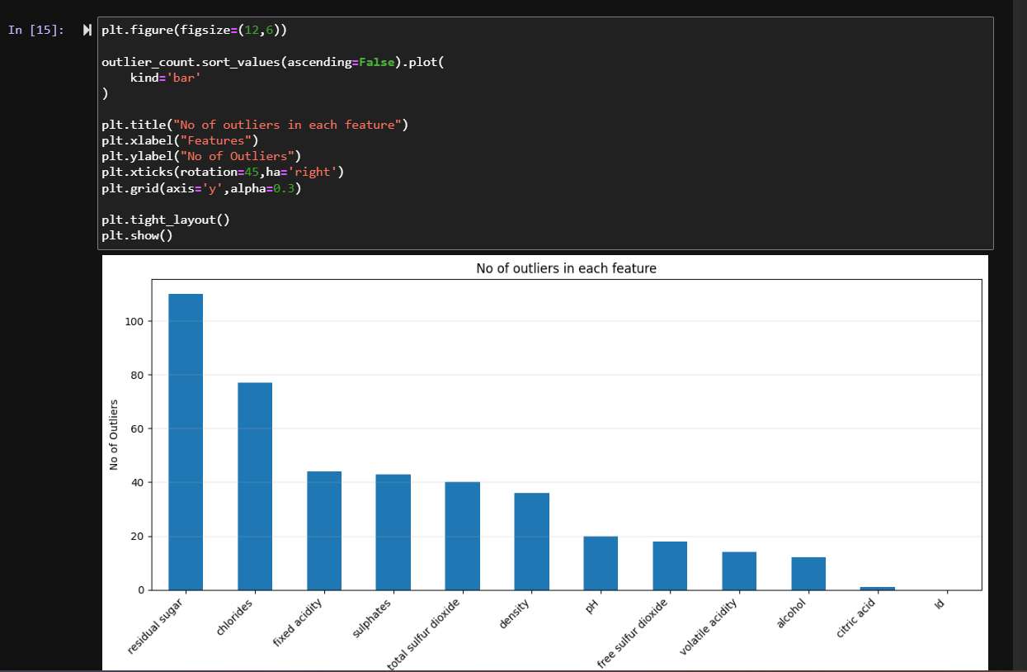this command is the visual representation for outlier bargraph In each column in descending order.
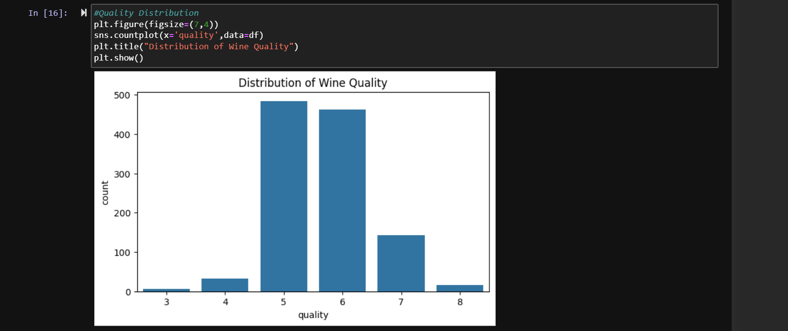
This command shows how many wines belong to each quality.
Quality 3 has least samples while the quality 5 as maximum wine samples

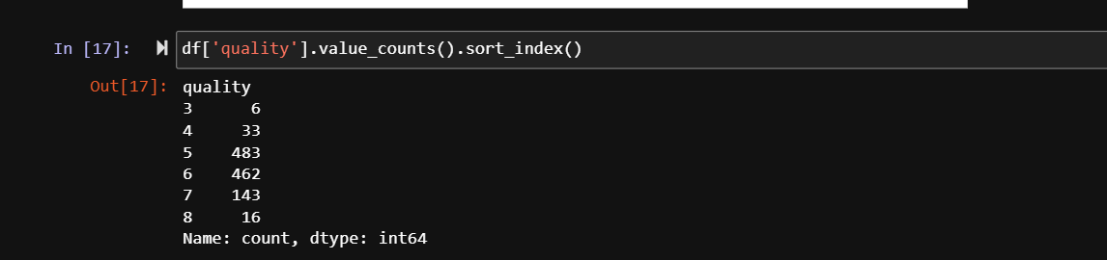
This command prints quality and how many wines come under each quality.
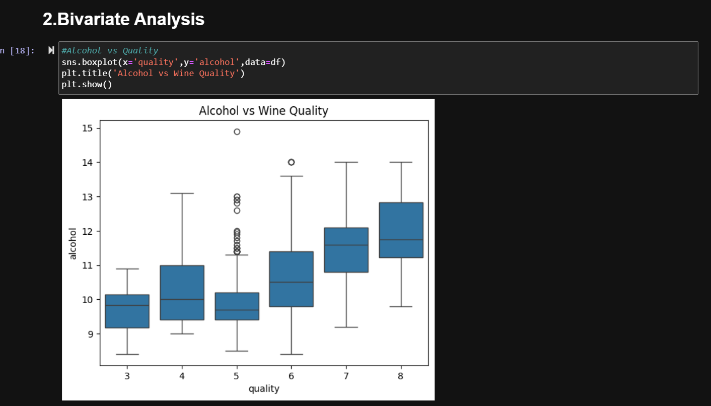
This command shows a scatterplot between alcohol and quality. It helps to understand relation between two variables.

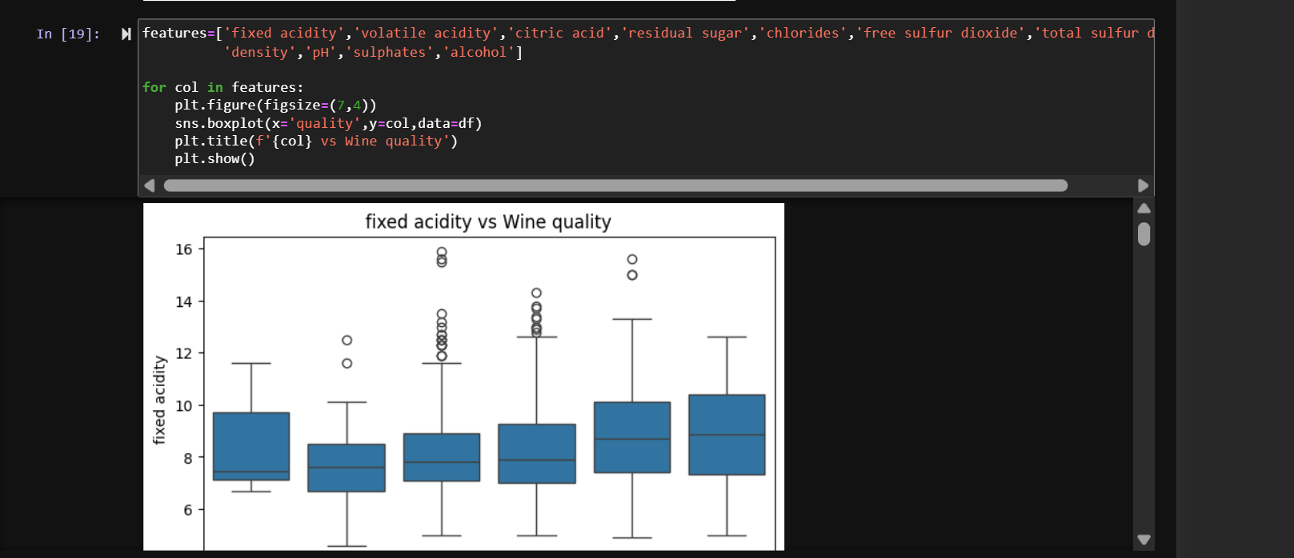this command prints scatterplot for all columns vs wine quality. This helps to understand relation between wine quality and all the other features(columns).

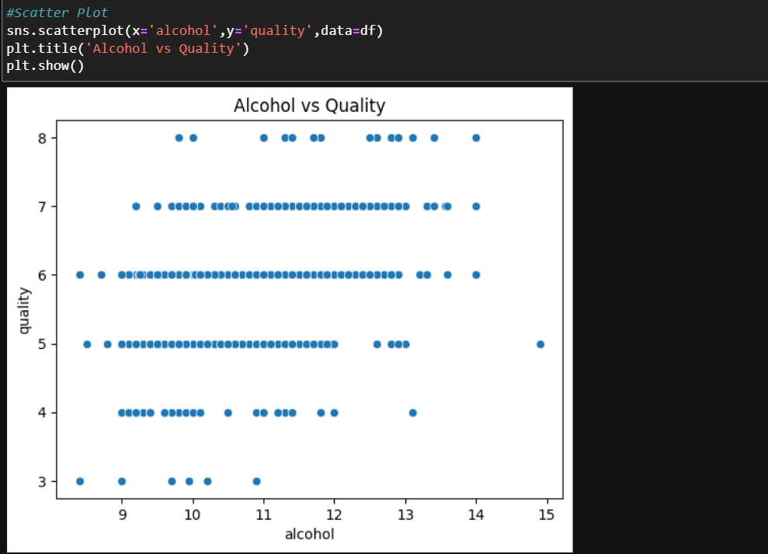
This command prints the scatterplot between alcohol and quality,
Wine with alcohol % around 9% are usually in quality 4 and 5 while those with 12% belong to level 7.

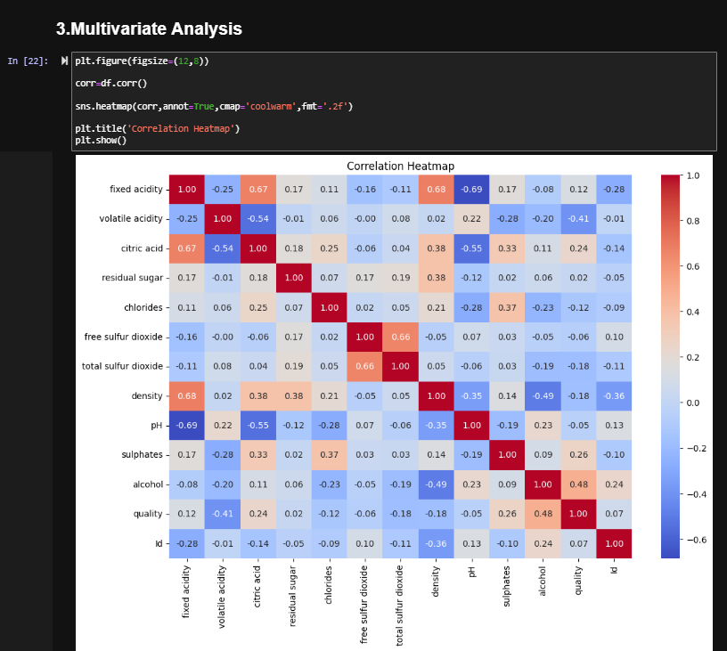
This command prints correlation heatmap for all variables present in dataset , this helps to analyze dataset with many variables at once.

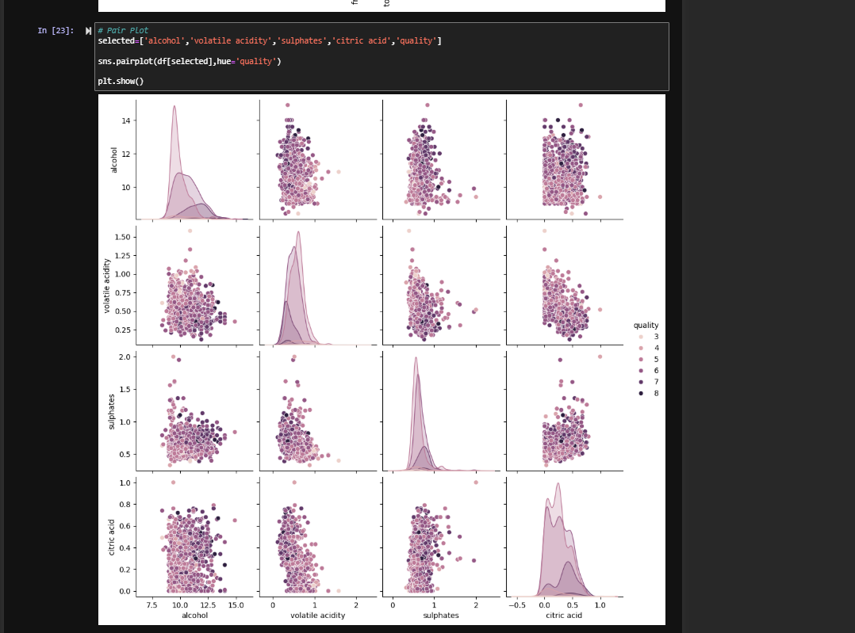 We used the pair plot to visualize relationships between multiple variables (alcohol, volatile acidity, sulphates, citric acid) and quality all at once, instead of plotting each separately.
This makes it faster to spot which features actually separate high vs low quality wines.
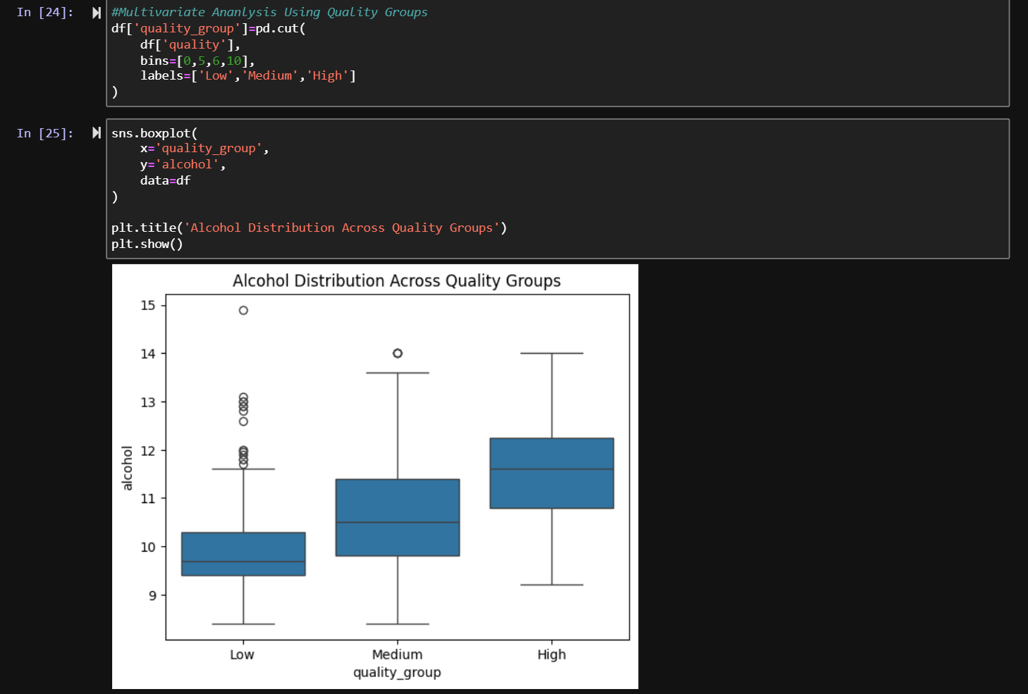
The first command divides the quality into different ranges like quality from 0-5 as low,
5 -6 as medium and 6-10 as high.
The second command is a boxplot between alcohol % and quality like low medium and high.
2nd command helps us identify that as the rating of quality increases, the alcholo % also increases.

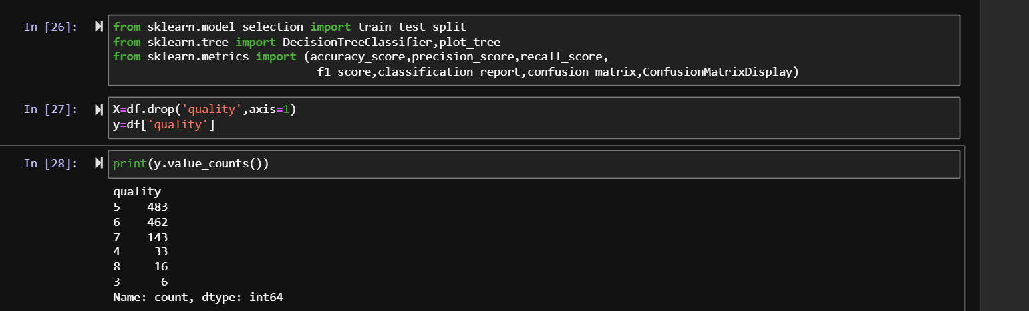the first command imports libraries for our next operations .
The second command drops the quality column from X which is our input and putting it into y which is our output .

The third command prints the number of alcohol in each quality.

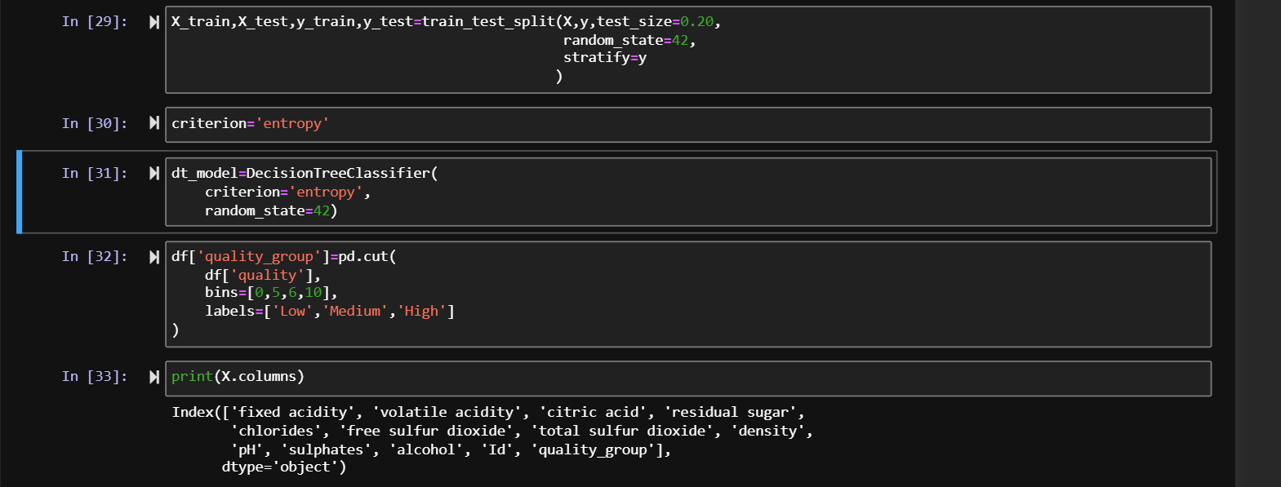
The first command divides the dataset into training and testing size.
The second command defines a variable entropy which helps us split our tree later.
The third command is making a decision tree which uses entropy as splitting criterion
The last command prints all the columns present in X ie our input features.

This command prints all the columns in X which are non numeric since we need only numeric values to train our decision tree

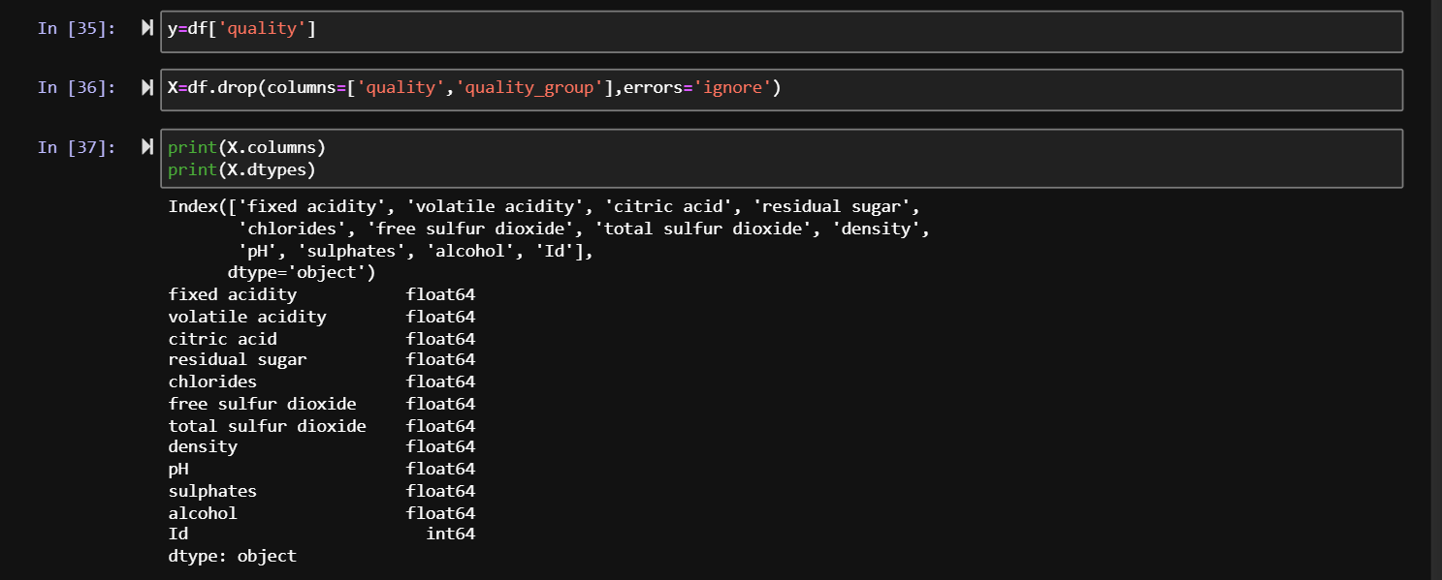this command drops the quality data from X since quality is the output column which should be present only in y, then we print X to confirm if the quality column is droped from X or not.

This command divides the training data and testing data into ratio of 0.8:0.2
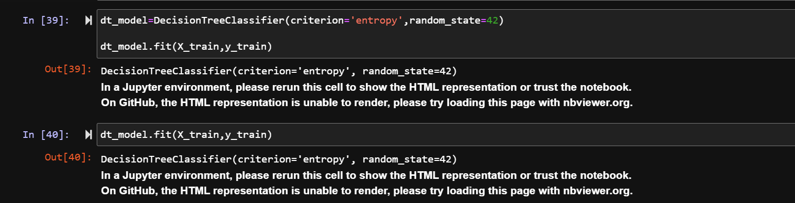
This command proves that our model was trained successfully on basis on entropy as a criterion.

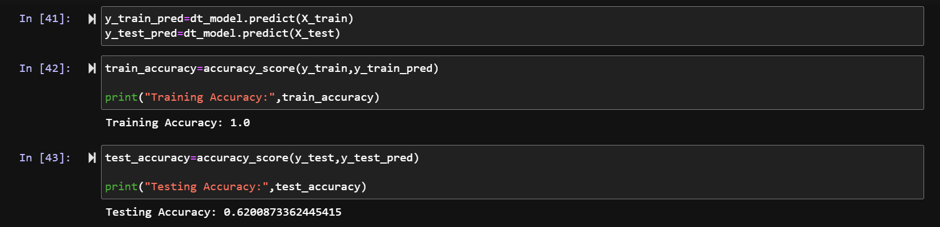
Cell 41 runs the trained model on our testing data of X .
The output is showing accuracy as 1 which means model is overfitted.this means out model has memorised the training data instead of understanding the pattern.

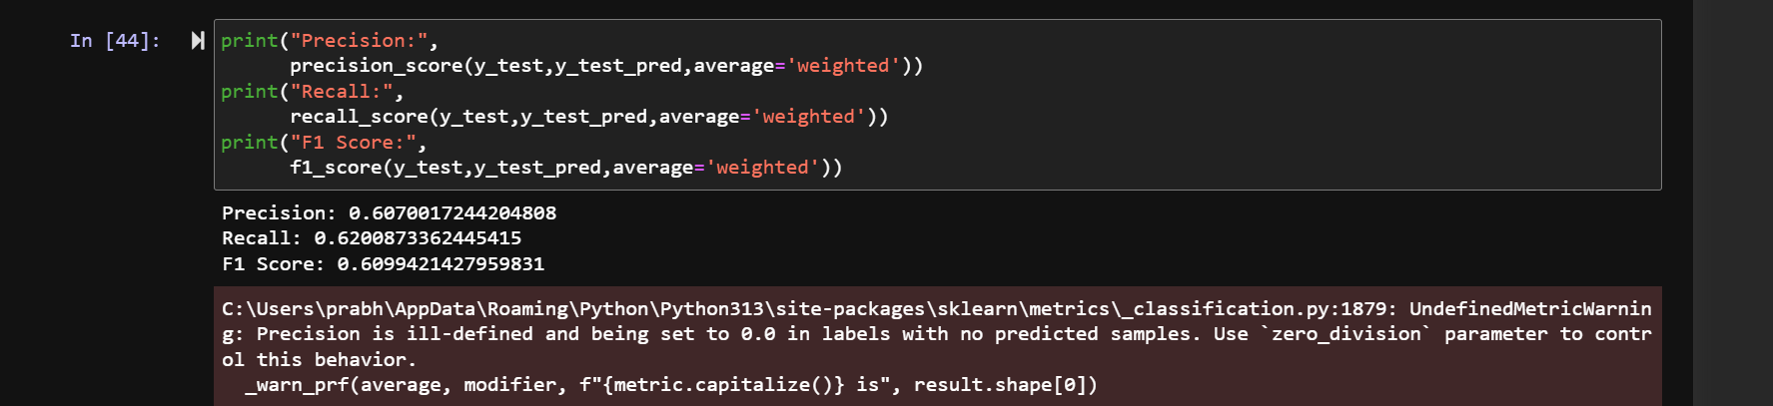
This prints the precision means how much did our model predicted correctly,
Recall means how many correct values did the model recalled and f1 score is mix of both precision and recall.
Since all values come near to 60% means out model is falling short on accuracy .
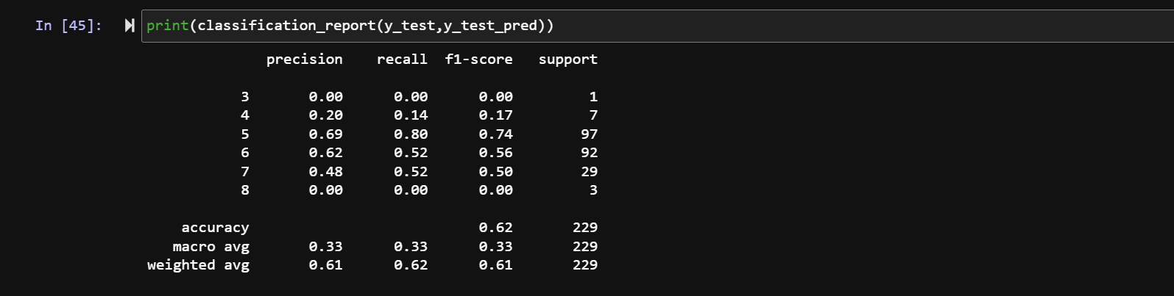
This command shows individual values for recall, precision and f1 score for each quality as quality is our output(y).

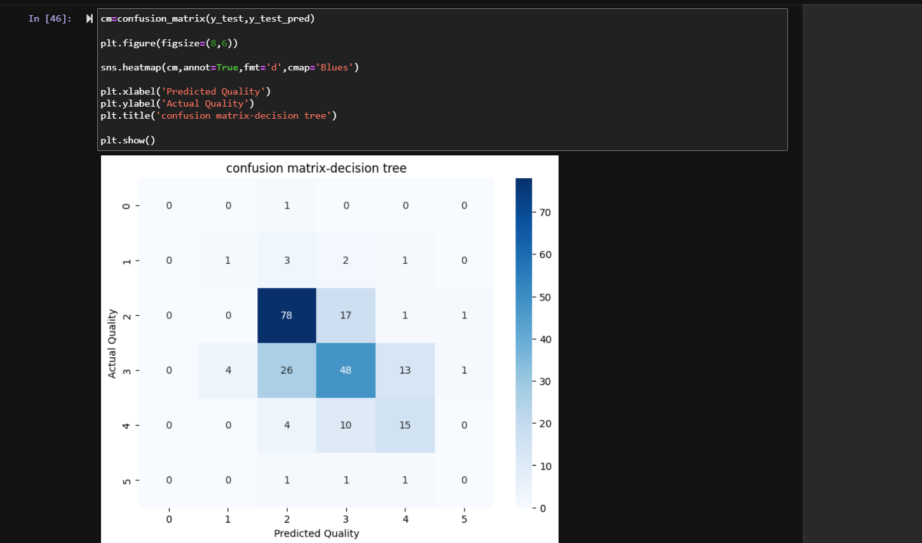this command prints a confusion matrix for predicted values and actual values. Dark color means that model predicted that area accurately and light means incorrect predictions.

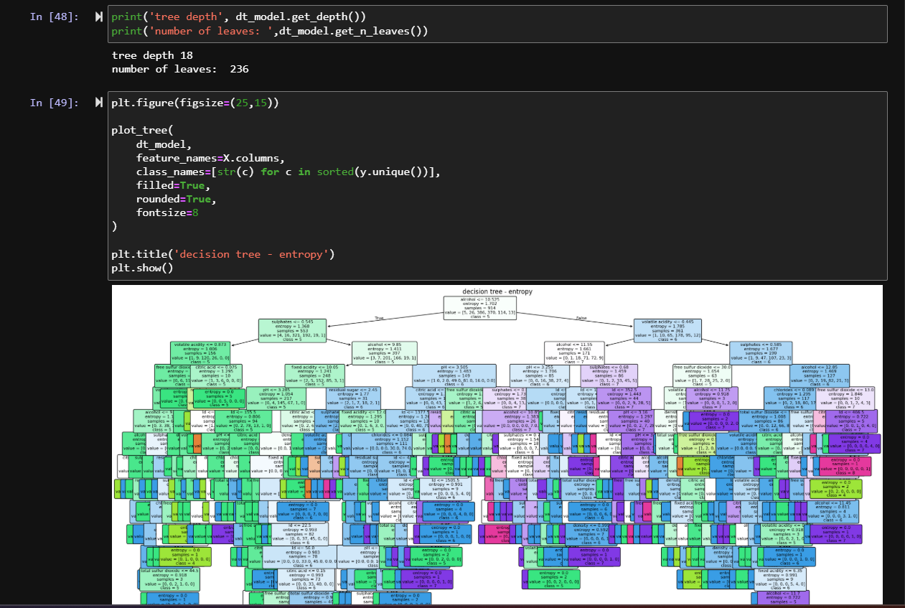this command prints the decision tree visual for us to understand it more easily,

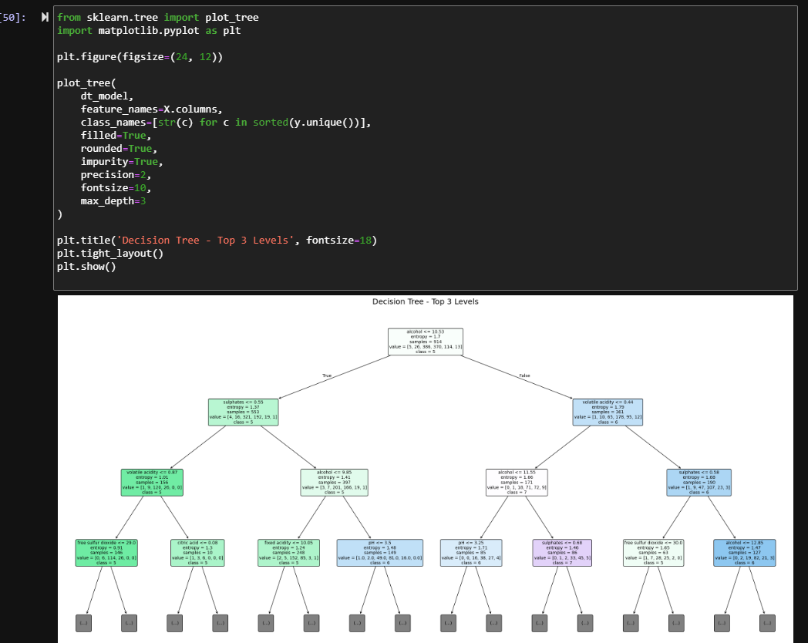here we capped the limit to level 5 only for clear understanding for us.

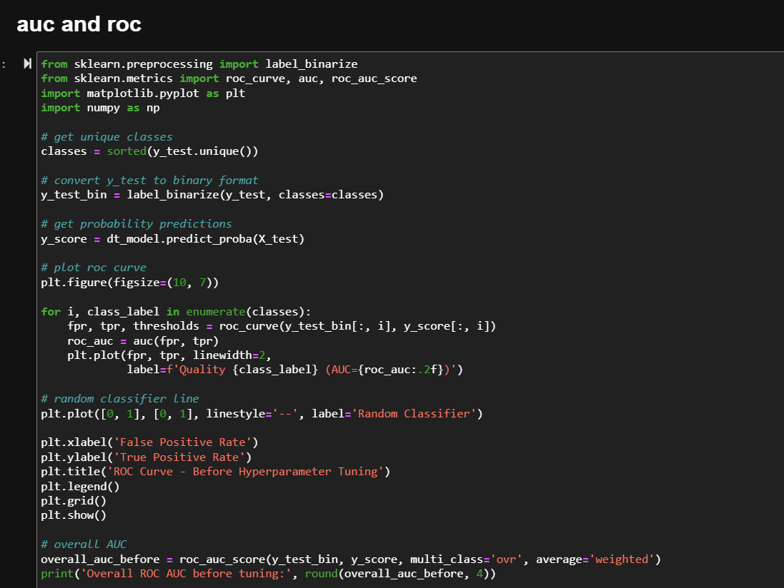this command shows the auc (area under curve) and roc.
Library binarize gives yes or no values to dataset .
We binarize because roc works only in binary and not on basis of classes.
The loop calculate roc and auc for each feature of X and then plot it as a line.
We then draw a diagonal line for baseline comparison,
if roc curve lies below this line means model is wrong as guessing ,
if roc curve lies on or near this line means model is predicting on basis of probability.
If roc curve lies above this line means model is working with good accuracy.

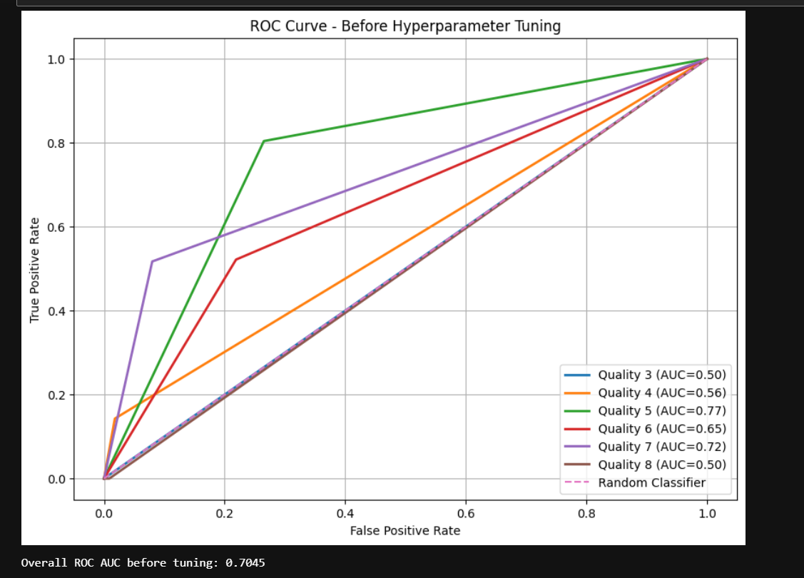

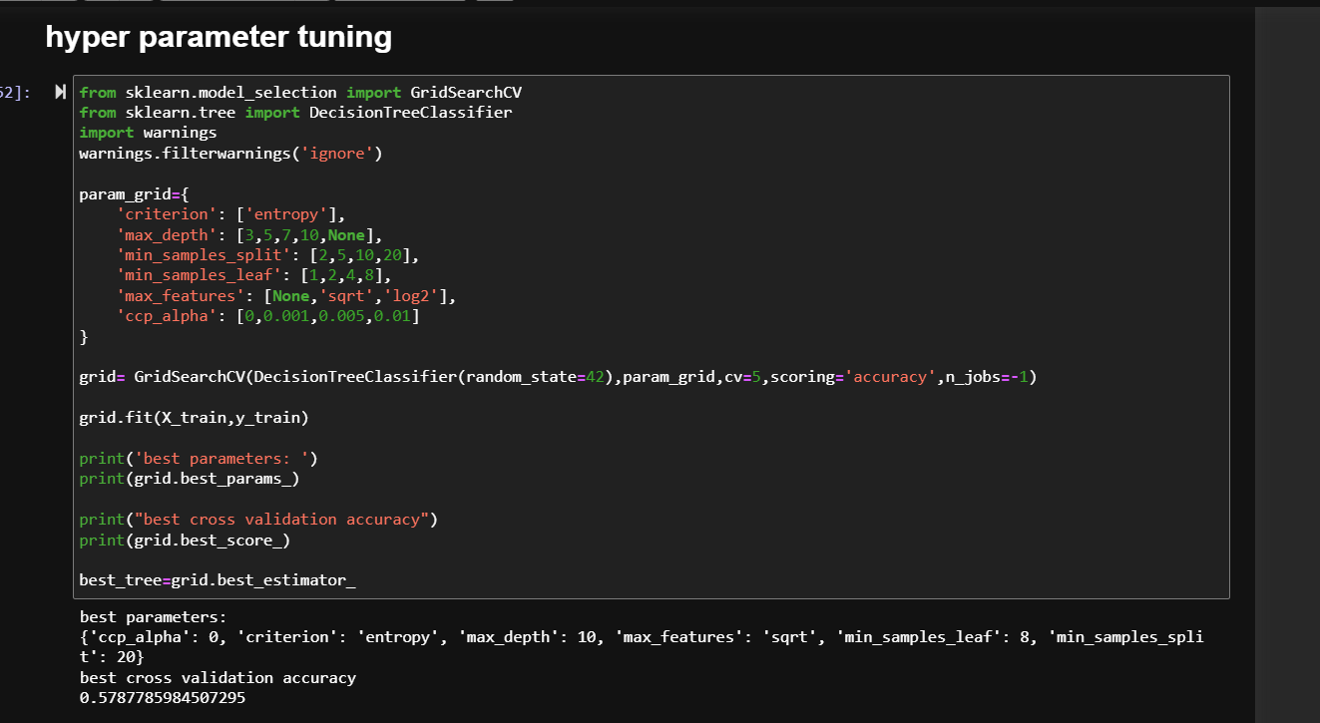
This command runs various runs for best possible decision tree and returns the parameters which when combined together prints the best possible decision tree

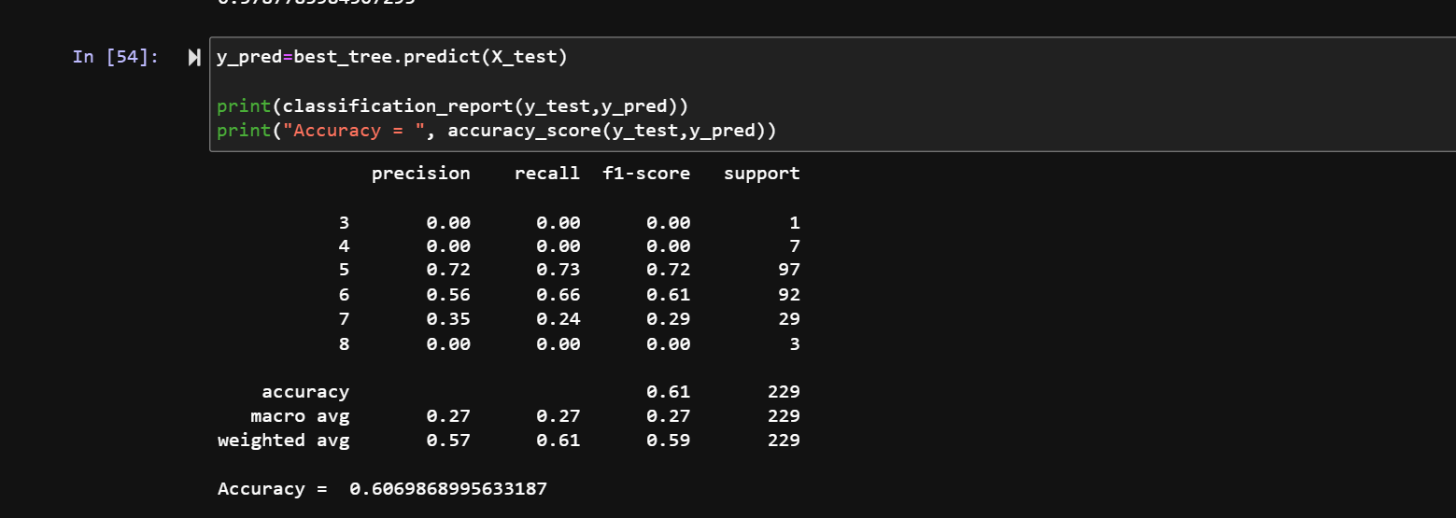
This command trains our model again on new parameters ,
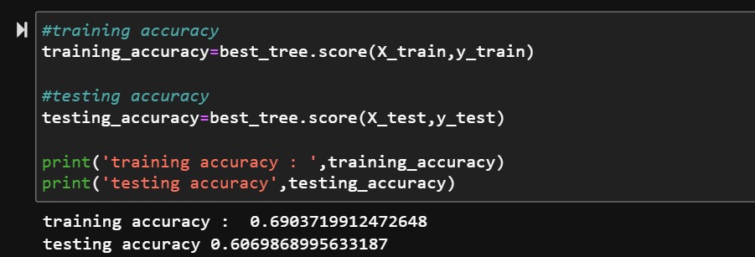this command check the training and testing accuracy of our model, earlier testing came out to be 1 means model was overfitted, now its 0.69 means model Is not overfitted . means out hyperparameter tunning worked successfully

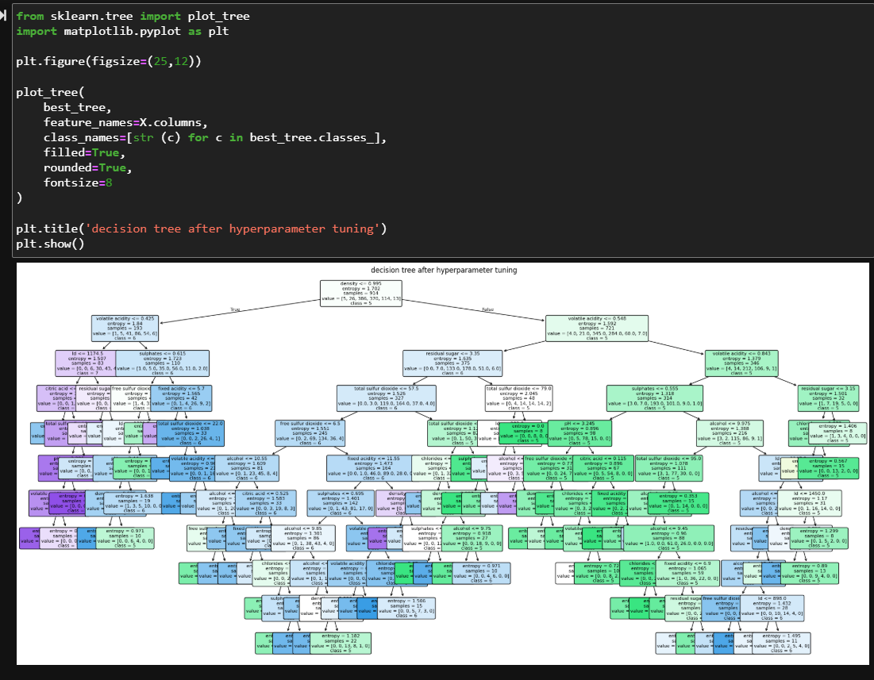
This command plots decision tree on basis of new parameters for our new model which is not overfitted like the earlier one.

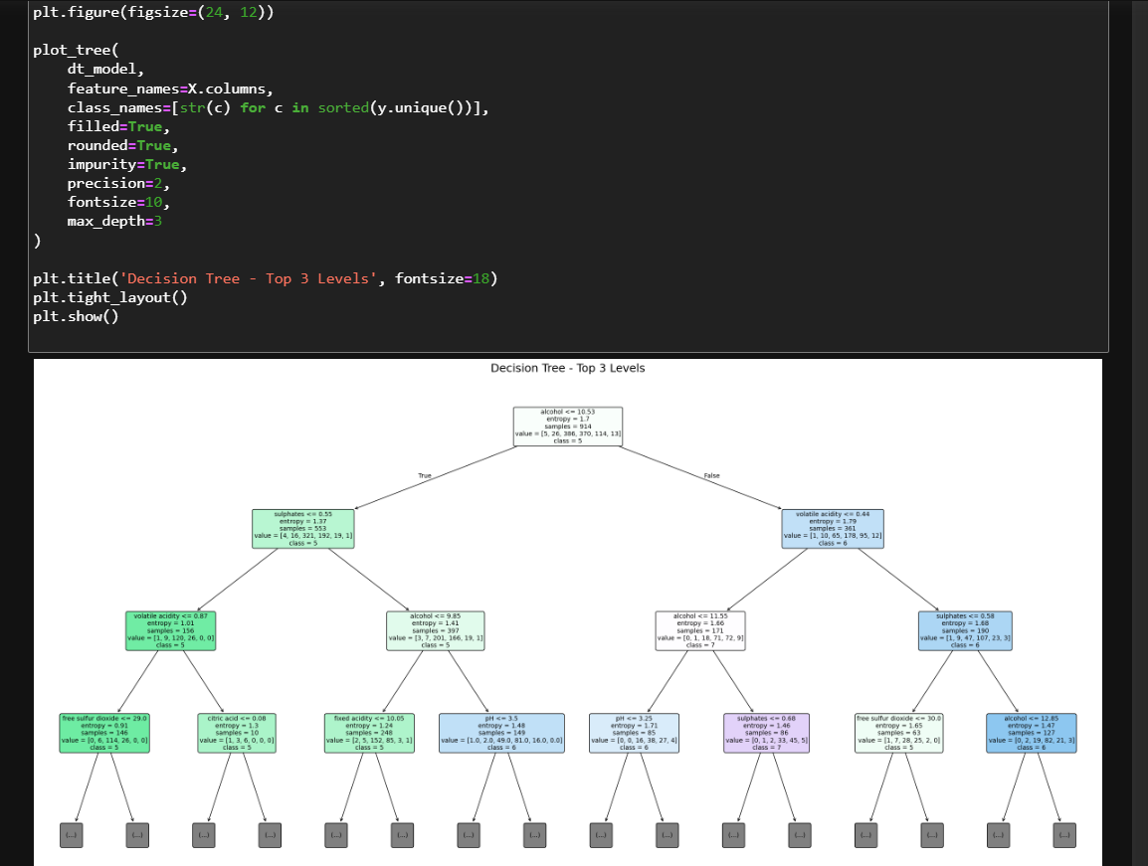this command plots the same tree but with capped level

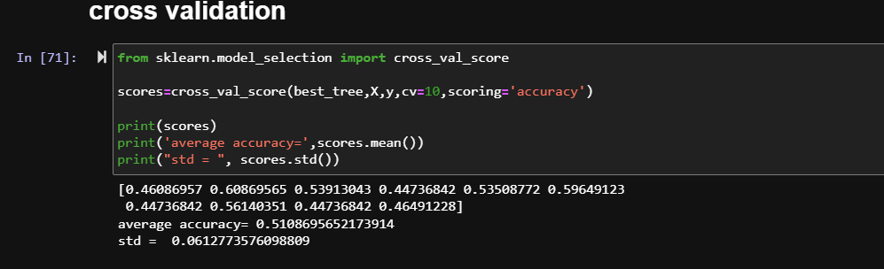
We are now training our model multiple times by changing the training and testing data, we choose 10 parts and now we train it on 9 parts and test on 1 part and in each iteration this testing and training data changes making our model better in predictions.

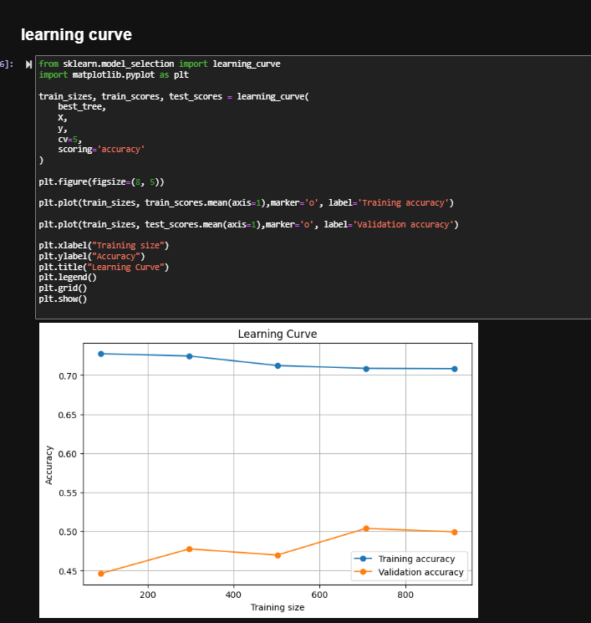
This command shows visuals of learning curve and validation curve, training curve means how model performed on training data, here it has given 0.7 accuracy.
But on validation curve its around 0,5 means model is still not very accurate when tested on testing data via cross validation.
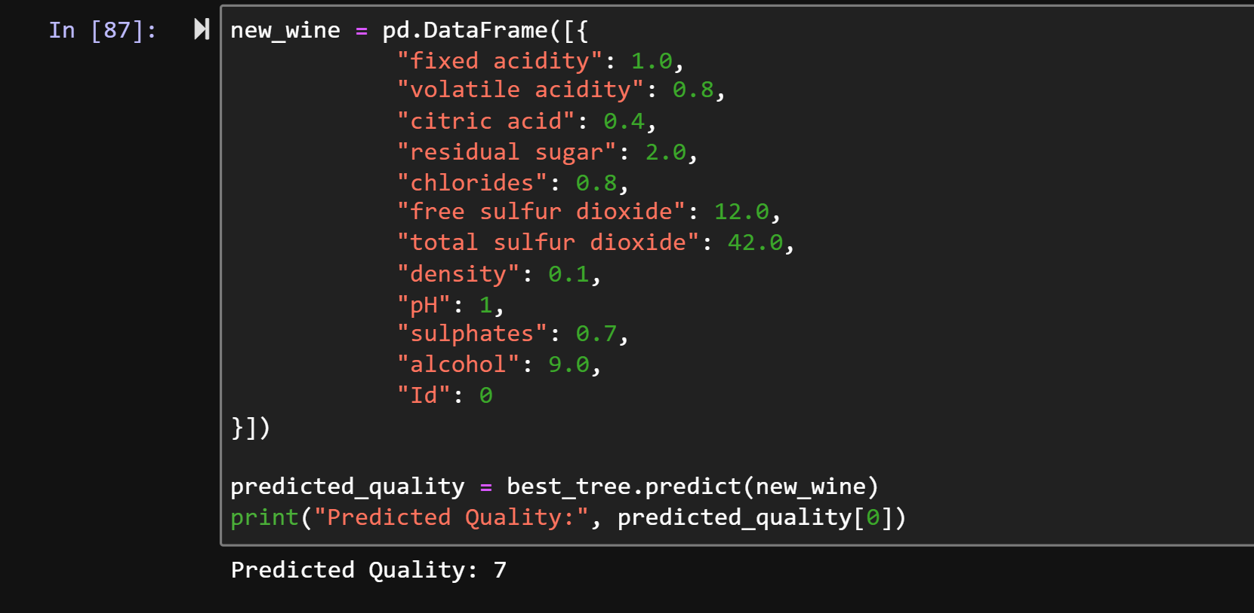
This command creates a new type of wine based on the criterias we have given to it and predicts the quality of the new sample of wine. This is command used in real life to check what new types of wines can be created using our criterias for new sample.

VIVA QUESTIONS
Why did we use a Decision Tree Classifier?
Because we want to predict wine quality, which is a rating (3 to 8), not a continuous number. Decision trees are good for this kind of prediction problem.
Why did you drop the quality and Id columns from X?
Quality is what we are trying to predict, so it can't also be an input, and Id is just a serial number with no real connection to wine quality — keeping either would confuse the model.
Training accuracy was 100% but testing accuracy was only 62% — what does this mean?
This means the model memorized the training data instead of actually learning patterns this problem is called overfitting.
How did we fix the overfitting problem?
We used GridSearchCV to try different tree settings and pick the best ones. This gave us a smaller, simpler tree that performs more consistently on new data.
Why did some quality classes (like 3 and 8) get 0% precision and recall?
Because there were very few examples of those quality ratings in the dataset, so the model didn't get enough chances to learn them properly

